Press Release Sculpteo
Paris & San Francisco, June 2nd, 2020

Sculpteo’s 6th Edition of The State of 3D Printing:
Increased Production with 3D Printing Pushes Innovation!

- Scaled production with 3D printing reaches 52% vs 17% in 2015,
- 70% see 3D printing as a strength and competitive advantage,
- 68% willing to use additive manufacturing for more applications,
- 30% investments of more than $ 100K,
- but 59% say the price is still a limit,
- and more than 55% demand for new materials and technology innovation…

Sculpteo, leader in online 3D printing and digital manufacturing, releases its sixth edition of The State of 3D Printing, the annual international survey that offers a complete overview of the additive manufacturing world to help improve 3D printing business strategy. This year’s survey shows that 3D printing continues to radically change the landscape of industrial manufacturing. Industries have noted: these new technologies offer a major asset in improving their whole production process and boosting their business strategies. While the technology's benefits for companies leads to more spending, the materials and the technology itself will substantially evolve over the upcoming years. Clément Moreau, CEO and co-founder of Sculpteo, will discuss the key findings of the report during a Webinar on Wed, Jun 17, 2020 4:00 PM - 4:30 PM CEST.

Each year Sculpteo collects data about the additive manufacturing industry to highlight key trends about this dynamic and rapidly evolving industry. Over 1,600 respondents answered the survey, making it the biggest and most representative edition. It is also the most diverse: respondents come from Europe (48,1%), Asia (13,1%), while North America increased by 11,6% in one year reaching nearly 30% of participants. 62% of respondents have an engineering background and 22% are CEOs. They come from a variety of industry segments ranging from industrial goods to education or healthcare.

According to Clément Moreau, CEO and co-founder of Sculpteo: "No doubt that 3D printing is changing the manufacturing landscape. Our sixth study shows that many industries are consolidating their use of 3D printing as its role becomes more defined within their manufacturing processes. Users are becoming more mature, but also more eager to try new applications, technologies and materials. With additive manufacturing evolving at such a rapid pace, the best is yet to come!”

3D printing is consolidating its position in certain manufacturing industries
Many industries are beginning to consolidate their use of 3D printing as the role of 3D printing becomes more defined within their manufacturing processes. Users are becoming more mature in their knowledge and application of additive manufacturing: 80% of respondents have used 3D printing for more than 2 years (+7% vs 2019) and 31% even use it daily.

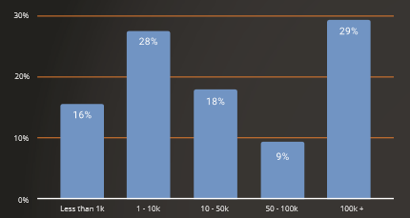
In terms of investments, 33% of the respondents expect up to a 50% increase this year, more conservative than previous year. The study shows that nearly 30% of users invested more than 100k in 3D printing this year, up 5% than 2019.

Moving additive manufacturing from prototyping to production technology
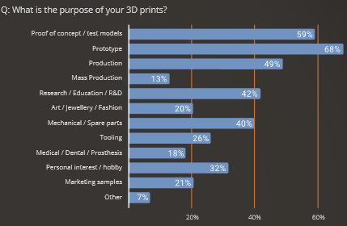
Once again, production with 3D printing continues to rise reaching 52% in 2020 versus 48% in 2019. 68% is still used for prototyping. Across all continents, two main factors are commonly viewed as limiting the potential for adoption of 3D printing: the knowledge gap which is stable at 51%, and cost of entry for 59% of respondents, nearly 10% lower than last year. 67% of respondents from North America also see budget as the greatest barrier to expending the use of 3D printing versus 44% in Europe.

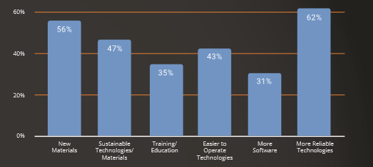
Additive manufacturing can accelerate its adoption with new material and applications!
Yet companies remain confident: 68% of respondents are eager to use additive manufacturing for more applications and 44% will start using new 3D printing technologies. How can additive manufacturing accelerate its adoption? New materials and reliable technologies are demanded by more than 55% of the industry. To accelerate the adoption of 3D Printing in any manufacturing ecosystem, machine capabilities and consistency of 3D printed parts must also develop for more than 80% of users.

Access the full survey: stateof3dprinting.com

Highlights of the State of 3D Printing 2020 will be discussed with Clément Moreau, CEO and co-founder of Sculpteo, during a Webinar
Wednesday, June 17, 2020 4:00 PM - 4:30 PM CEST
To learn more and sign up, please click here

About Sculpteo
Sculpteo, pioneer and specialist of digital manufacturing, offers a service of online 3D printing. Sculpteo provides an online platform to securely upload 3D files and select from 75+ materials and finishing options. Professional engineers and technicians produce parts on industrial 3D printing technologies before sending them to businesses and individuals around the world. Based in Paris and San Francisco, Sculpteo offers on-demand 3D printing and manufacturing at a large scale for start-ups, SMEs and design studios. Sculpteo offers its professional 3D printing service alongside its expert Design Studio to help businesses integrate additive manufacturing into their product development and production systems. Sculpteo was created in 2009 by Eric Carreel and Clément Moreau. It was acquired by BASF New Business GmbH in November 2019.

For more information: www.sculpteo.com

About BASF New Business
BASF New Business GmbH (BNB) searches out long-term trends and innovative topics in industry and society as well as future markets, analyzes their growth potential and checks whether potential new business areas are suitable for BASF. Its activities are focused on the client sectors of transportation, building and construction, consumer goods, health & nutrition, electronics, agriculture, and energy & resources where new business opportunities outside existing BASF businesses are identified. BNB then progressively builds the most promising business concepts as new business areas for BASF. BNB concentrates on new chemical-based materials, technologies and system solutions, also promoting technological progress through actively driving the development of new products. To evaluate the technology and the market, BNB works closely with BASF‘s global research platforms and specialist divisions. In addition, BNB cooperates with research institutes, universities, startups and industrial partners. The subsidiary BASF Venture Capital invests directly in startups working in strategically relevant technology fields.

For more information please visit: www.basf-new-business.com.

About BASF 3D Printing Solutions
BASF 3D Printing Solutions GmbH, headquartered in Heidelberg, Germany, is a 100% subsidiary of BASF New Business GmbH. It focuses on establishing and expanding the business under the Forward AM brand with advanced materials, system solutions, components and services in the field of 3D printing. BASF 3D Printing Solutions is organized into startup-like structures to serve customers in the dynamic 3D printing market. It cooperates closely with the global research platforms and application technologies of various departments at BASF as well as with research institutes, universities, startups and industrial partners. Potential customers are primarily companies that intend to use 3D printing for industrial manufacturing. Typical industries include automotive, aerospace, and consumer goods.

For further information please visit: www.forward-am.com.

Sculpteo Press Contacts
Jean-François Kitten - jfk@sculpteo.com +33(0) 6 11 29 30 28 / +33(0)9 72 33 47 63
Ilinca Spita – i.spita@licencek.com +33(0)1 45 03 21 77
Badr Rar – b.rar@licencek.com +33(0)1 45 03 21 77

